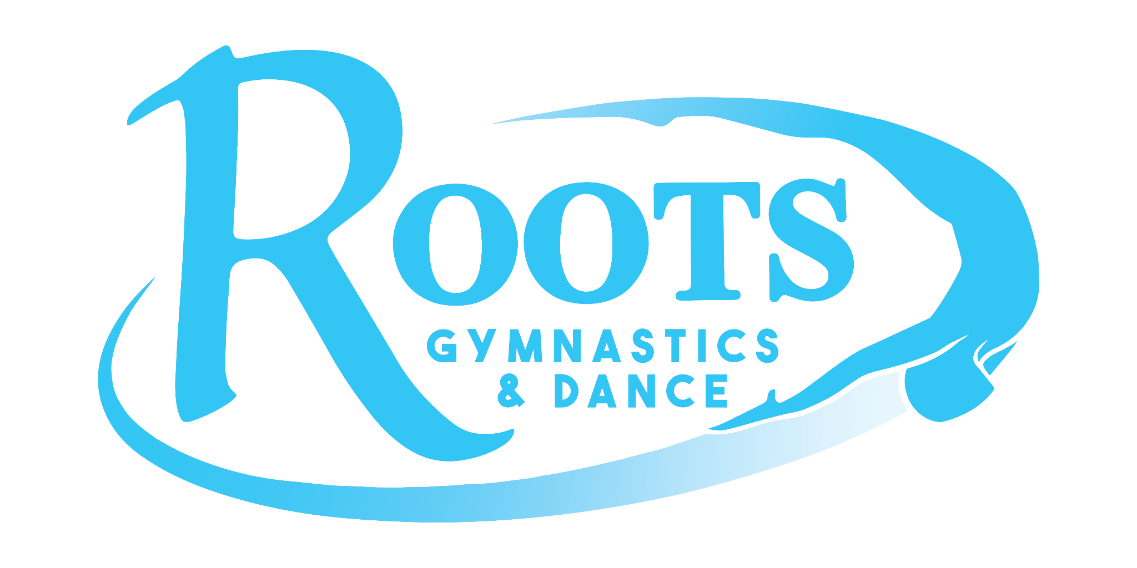
August 2024

Dear Missoula Community Member,

Roots Gymnastics and Dance Booster Club is a not-for-profit corporation directed by a group of parent volunteers committed to raising funds for our competitive youth at Roots Gymnastics and Dance. These teams include our Acro Performance Teams, Boys Competitive Gymnastics Team, Girls Competitive Gymnastics Team, and R.A.D. (acro-dance competitive teams). Performance and competitive opportunities are essential to all the youth supported by Roots Gymnastics and Dance Booster Club. These opportunities help the children set and obtain goals, receive constructive feedback, provide team bonding experiences, and promote a connection with our community by showcasing their amazing abilities and skills.

Please consider a sponsorship contribution to our athletes. Your sponsorship will contribute to the cost of traveling to gymnastics meets, dance competitions and costume fees for performances. You will be helping one of our more than 120 competitive team members travel to meets and competitions all over the U.S. Booster Club also helps provide extra training opportunities to all of our team members.

The following pages list sponsorship levels. A donation to Roots Gymnastics and Dance Booster Club is greatly appreciated. Your generosity will make a difference in our community by supporting a positive outlet for another segment of Missoula’s youth.

Thank you in advance for your support!

Sincerely,

Roots Gymnastics and Dance Booster Club

Roots Gymnastics and Dance Booster Club
216 Commerce Street
Missoula, Montana 59808
(406) 728-4258
rootsboosterclub@gmail.com

