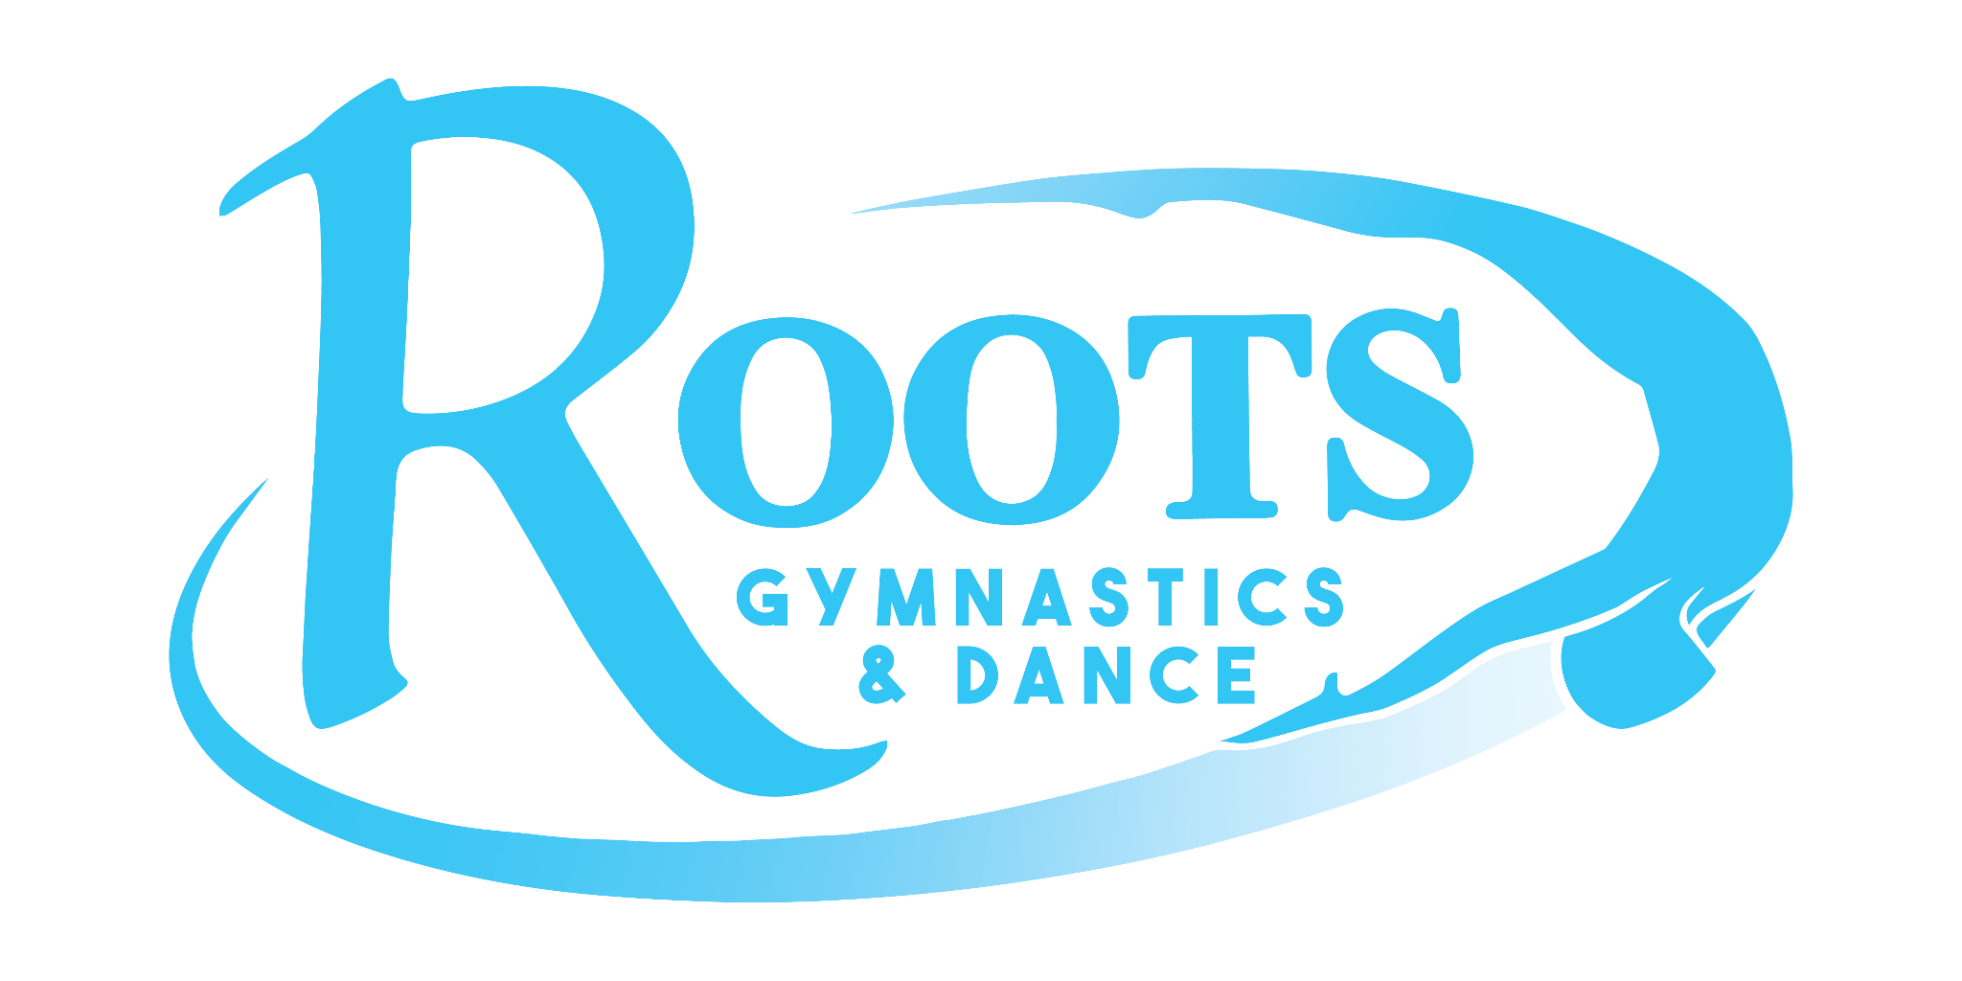

For Sponsorship please make checks payable to Roots Booster Club and send them to:

Attn: RGD Booster Club
216 Commerce Street
Missoula, MT 59808

Business Logos: Depending on the sponsorship level we will need your company logo in order to put it on a banner, add it to our slideshow, and list it on social media.

All logos must be emailed to rootsboosterclub@gmail.com in JPEG format.

Your sponsorship is valid for one calendar year.

For questions regarding sponsorship opportunities, please contact Stephanie, Kristen, or Rose at rootsboosterclub@gmail.com

Roots Gymnastics and Dance Booster Club
216 Commerce Street
Missoula, Montana 59808
(406) 728-4258
rootsboosterclub@gmail.com

